Convert the Temperature

CODE:

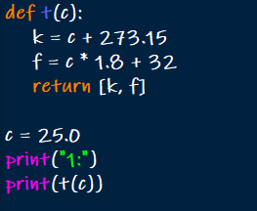

OUTPUT:



Number of Subarrays With LCM Equal to K

CODE:

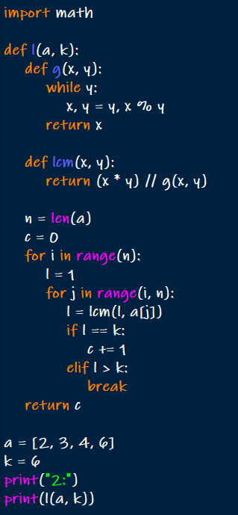

OUTPUT:



Minimum Number of Operations to Sort a Binary Tree by Level

CODE:

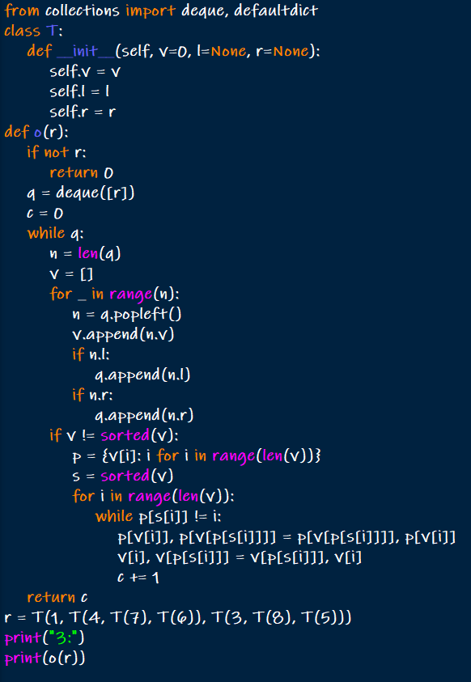

OUTPUT:



Maximum Number of Non-overlapping Palindrome Substrings

CODE:

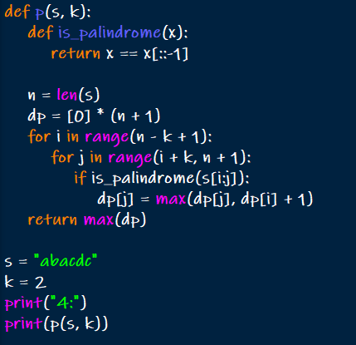

OUTPUT:



Minimum Cost to Buy Apples

CODE:

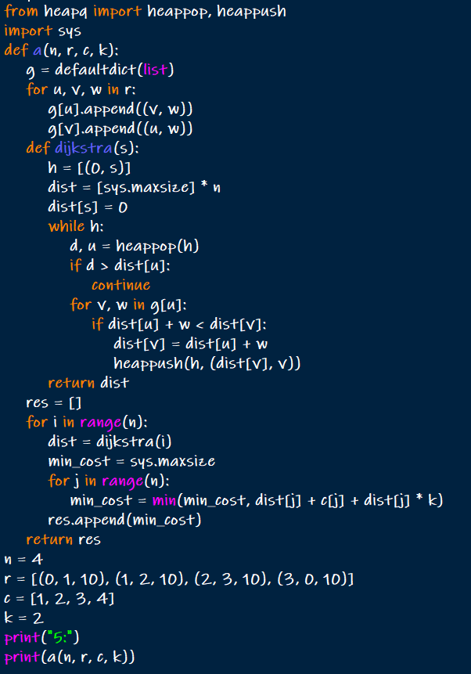

OUTPUT:



Number of Unequal Triplets in Array

CODE:

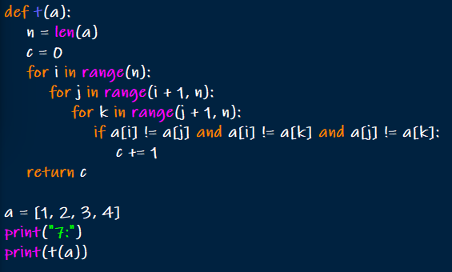

OUTPUT:



Closest Nodes Queries in a Binary Search Tree

CODE:

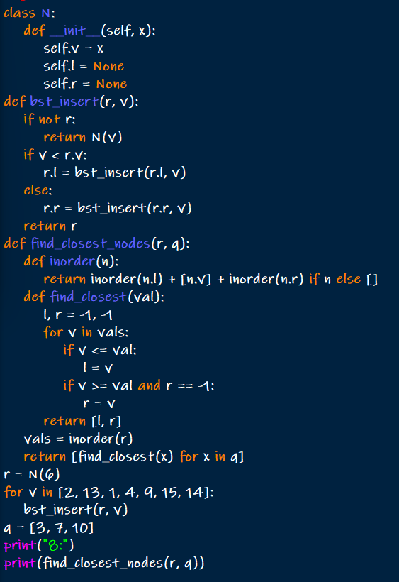

OUTPUT:



Minimum Fuel Cost to Report to the Capital

CODE:

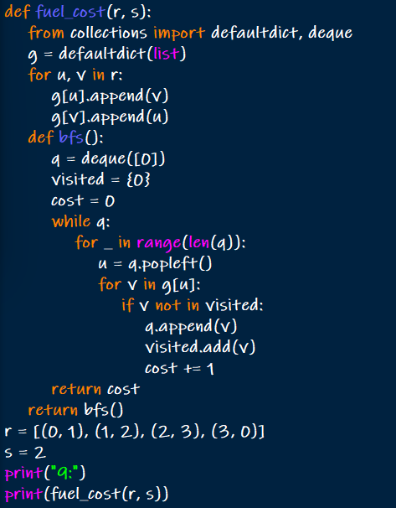

OUTPUT:



Number of Beautiful Partitions

CODE:

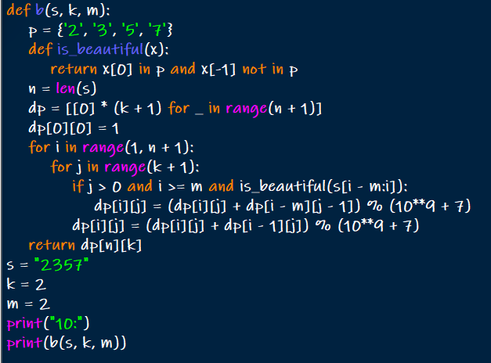

OUTPUT:

